S12
Two-Variable Data Analysis
Line of Best Fit
A line of best fit = a straight line that represents a trend in the scatter plot as long as the pattern is more or less linear. It may pass through some points, no points or all points, with about half the points above the line and half the points below the line.
A solid line represents continuous data that are constantly changing.
A dashed line represents discrete data that change only in steps.

Linear Correlation = a relationship in which a change in one variable tends to correspond to a proportional change in another variable.

Correlation coefficient = r = s measure of how well a linear model fits a two-variable set of data.
- Values of r between -1 and 0 indicate a negative correlation, so the line of best fit has a negative slope.

- r=0 indicates that there is no linear correlation

- values of r between 0 and +1 indicate a positive correlation, so the line of best fit has a positive slope.

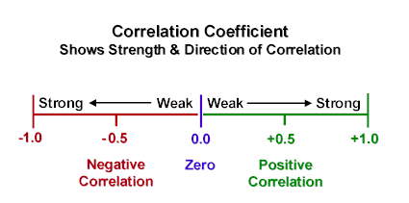

Linear Regression = mathematical process that determines the line of best fit.

Example:

- Plot the following data:

Variable 1 [s] | 2 | 1 | 3 | 4 | 5 | 3 | 6 | 10 | 9 | 10 | 4 | 6
Variable 2  [m] | 9 | 12 | 7 | 6 | 8 | 6 | 2 | 1 | 2 | 2 | 8 | 4

- Draw a line of best fit

- Determine the equation of your line of best fit. Compare your line and equation with 4 other classmates. Discuss any differences.

