PC11
Solving Quadratic Equations by Square Root Principle
- This method is very fast when solving an equation that is either in vertex form or in standard form where b=0.
- This method makes is also very obvious when the quadratic equation has exactly one solution: $Rx^{2}=0$
- Any other form will result in two or no real solutions.
- It is possible to solve an equation in standard form using the square root principle even when b $≠$ 0, but you would have to complete the square first. It is much faster to use the quadratic formula.

- Solve (find proposed solutions), check (using the original equation, show that LS=RS) and state.

Remember that whenever you take a square root of a positive number you will get two answers: the positive root (=the principal root) and the negative root. You have to remember the negative root because your calculator is not as smart as you are, and it does not give it to you.

Example 1: Solve $-5x^{2}+2=0$

Example 2: Solve ${-(x+3)}^{2}+16=0$

Practice:

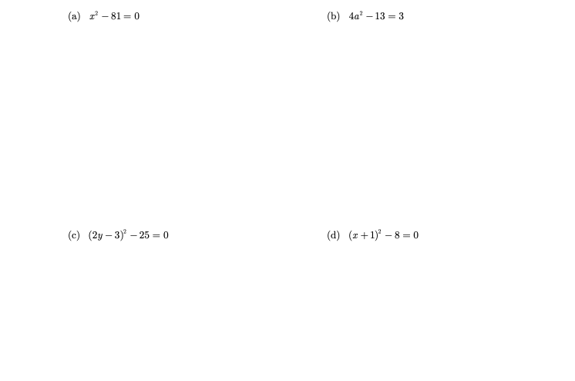
Answers: a) x=9 and x=-9, b) a=2 and a=-2, c) y=4 and y=-1, d) x=-1+2$√2$and x=-1-2$√$2

