PC11 Name:__________________

Determining The Equation of a Parabola given a Graph
1.
Observations:

Equation:

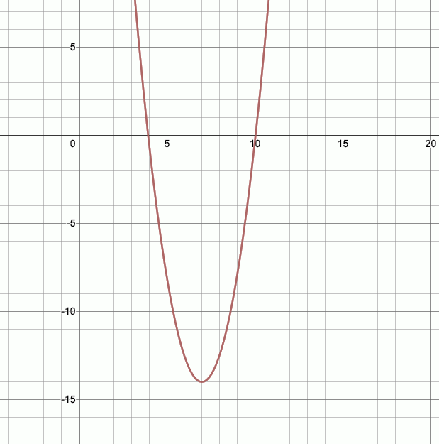

Determine the exact x-intercepts:

Determine the exact y-intercept

2.

Observations:

Equation:
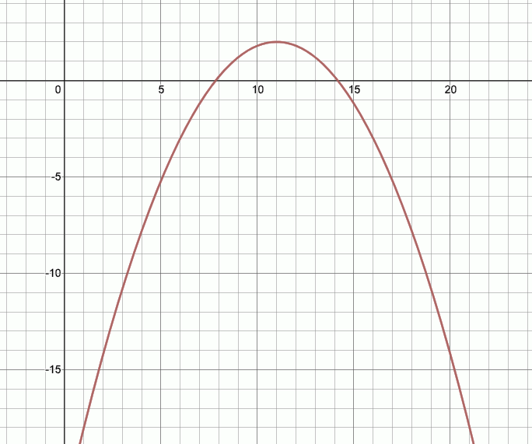

Determine the exact x-intercepts:

Determine the exact y-intercept

