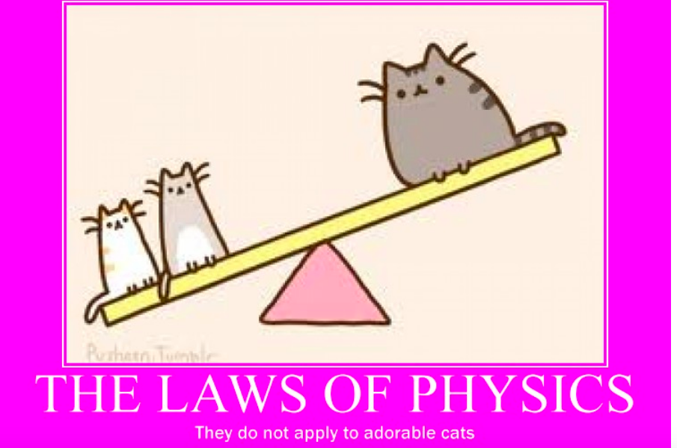

Please feel free to contact me at any time:
Teacher: Mrs. Dagmar Ferris
Room: # 145
E-mail: dagmar.ferris@yesnet.yk.ca

Welcome in Physics 11

Course Description: Physics 11 is an academic science course that builds on students’ knowledge of mathematics and science; and it is designed to encourage students to appreciate the science behind physical phenomena encountered on a daily basis and to prepare students for Physics 12. The overall framework for this course is anchored by the big ideas and learning standards given by the curriculum document.
(https://curriculum.gov.bc.ca/sites/curriculum.gov.bc.ca/files/curriculum/science/en_science_11_physics_elab.pdf)
The main goal of this course is to encourage students to look beyond calculations and appreciate the interconnectedness, patterns, and application of various physics concepts and to incorporate their newly acquired knowledge to solve problems.
Timeline:
Month | Topic
August | Vector and Scalar Quantities, Vectors, Graph Interpretation, Kinematics
September | Kinematics continued: Projectile Motion  Dynamics: Newton’s Laws, Contact Forces, Equilibrium, Forces in Systems  Thermal Equilibrium
October | Work, Energy, Simple Machines  Power and Efficiency
November | Waves, Sound: properties and behaviour
December | Electric Circuits, Ohm’s Law, Kirchhoff’s Laws
January | Review and Final Exam

Resources required:
Physics Principles and Problems (McGraw-Hill)
- Textbook
Web – links to useful websites and videos will be posted on teacher’s website
Worksheets and handouts
Magazine and newspaper articles when applicable
Videos and movies related to chosen topics

Assessment and Evaluation Plan:

- Test topics and dates will be announced in advance. Students are encouraged to make an arrangement with their teacher to write a missed test as soon as they return to school after their excused absence. Students with excellent attendance record and work habits will be granted opportunities to rewrite tests with a low mark. Retesting can be scheduled for a lunch break or after school hours.

- Quizzes may NOT be announced in advance. There will NOT be an opportunity to “make up” a missed quiz. A grade of zero will be scored for a quiz missed due to lateness or unexcused absence. A student with an excused absence on the day of the quiz will not be penalized. Quizzes will be solely based on material presented in class or assigned for homework. Students, who did not miss any quizzes due to lateness or unexcused absence, will have a choice of dropping two quizzes with the lowest grade per term. Quizzes can have a written, oral, or a hands-on form.

- Assignments (group projects, in-class and other assignments) will be checked regularly, and may be collected without prior notice. It is expected student will demonstrate the steps leading to his/her answer in all work. Unsubstantiated work will not be credited as the process leading to an answer is often more valuable than the answer itself. Early and timely submissions of assignments will earn the right to resubmit either partial or entire work for a higher mark.

- Attendance and behaviour expectations for quizzes and tests are the same as the school’s expectations of students for final exams.

- Copying other’s work, enabling others to copy one’s work, and using unauthorized material during quizzes and tests is considered plagiarism. Plagiarism is a sever offence and it will be taken into consideration during student’s evaluation.

- Students are expected to clearly identify all the resources and references they use to complete any given project or assignment whenever applicable.

- Labs are an essential component of learning and experiencing physics, students are expected to complete all mandatory laboratory exercises and hand in all required lab reports. While completing lab exercises, it is of upmost importance that students conduct themselves with their safety and safety of others in mind and are respectful of school and other property. A student who compromises their safety, safety of others or intentionally damages property while conducting a lab experiment will not be able to complete the lab exercise and a mark of 0 will be assigned.

- Assignments, posters and projects that are submitted later than 3 days after the deadline will not be accepted unless a very serious reason for lateness exists.

- *Conversations among peers and with a teacher are essential components of assessment and evaluation. Peer talks and small group and whole-class discussions will be used to determine the level of understanding, to emphasise connections with already known and mastered material, and to allow students multiple opportunities to communicate their understanding and to voice their questions in a safe environment.

10. *Students’ ability to work independently, to effectively and respectfully cooperate with others, to assess their own work and the work of their peers, to set goals, and to plan strategies to achieve the goals will be observed, assessed and evaluated.

11. Final exams will be given in two parts; Part 1 before winter break and Part 2 in January during the first week of school after winter break. Final exam Part 2 will be in the form of lab exercises and lab reports; 3 best out of 5 possible will be assessed. Review will be given before Part 1 of the final exam.

CALCULATION OF CLASS WORK MARK:
FINAL MARK

Class work 80.0%
Final Assessments 20.0%
Total 100.0%

Tests 25.0%
Labs 20.0%
Quizzes and projects* 30.0%
Assignments and classroom participation* 25.0%

Total 100.0%

Specific policies/procedures for this course:
- Students are expected to show respect for their classmates and teacher(s) by arriving to class prepared and on time.
- Cell-phones, laptops, i-pods, i-pads and other electronic devices are not to be used by students while in class unless used for graphing or research.
- Students are expected to maintain the necessary work habits in order to adhere to the course schedule. It is the student’s responsibility to seek help during class or, by prior arrangement, outside of class time.
- Homework is an essential component of the course.
- Students are responsible for work missed due to absence. Extra help with missed material will be available after the student has obtained and attempted the missed material.
- Assignments, due dates, and study information will be available on my teacher page.
- Please feel free to contact me at any time: dagmar.ferris@yesnet.yk.ca
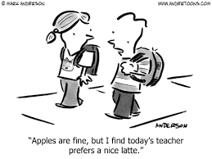

Scratch that, today’s teacher prefers that you show up on time and prepared to learn.

Please answer the following questions:
1.Why have you decided to take physics 11?

2. What are your expectations and goals regarding this course?

3. What do you expect from your teacher?

4. What are your post-secondary plans?

5. What areas of science are your favourite?

6. What areas of science, if any, do you find frustrating?

7. In general, what are you good at?

8. What would you like to improve on this semester? And how can I help you achieve your goals?

This handout is to inform students and parents/guardians of the expectations for this course. Please sign and return. Thank you.

Student full name: ______________________________________________ Student signature:__________________

Parent/Guardian signature:________________________________________ Date:____________________________

To Parent(s) or Guardian(s):
Please let me know if there is anything I should be aware of. Thank you.

