PHYSICS 12

ELECTRIC FIELD

- Electric Field is a vector quantity that describes the strength of the electric force per unit charge.
- Electric Field is measured in Newton per Coulomb [N/C]
- An electric field exists around any electrically charged (positive or negative) object.
- Direction of the electric field is given by what would a positive unit (=1.00 C) charge experience if placed in that field.

$$E=\frac{k q}{r^{2}}$$
$$E=\frac{F}{q}$$

OR

- Electric Field around a point charge

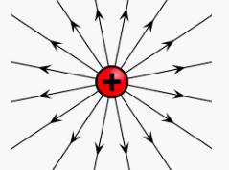 | 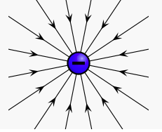

- Electric field around two charges
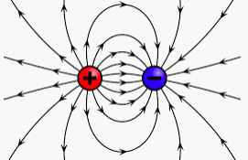 | 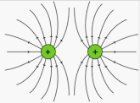

3. Electric field between two oppositely charged parallel plates

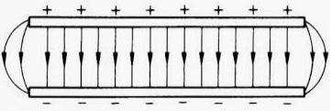

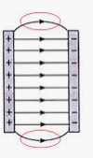
$$E=\frac{∆V}{d}$$
Where $∆V$is the potential difference between the two plates and d is the distance between the plates measured in meters.

Units:
V/m

- the lines and curves with arrows drawn around a charged object are called field lines. The more field lines and the greater the density of the field lines, the stronger the field.

